**Analysis on Ruchi Questionnaire**

**OBJECTIVES**:

To understand the awareness of faculty at higher education towards career planning and get enlightened about functions to be performed by faculty at higher education to progress in the teaching career and also rate of satisfaction of the faculty on their present job apart from knowing policies to retain competent faculty

**Analysis:**

We have a total of 150 faculty members and their age ranges from a minimum of 21 years to more than 60 years. As per the questionnaire, the age ranges are categorized into 5 different groups, each group having an age interval of 10 years starting from age 21.

From the below graph we can observe that most of the faculty at higher education falls under the age group 1 (21 to 30 years) with 72 faculty, 39 faculty in age group 2 (31 to 40 years), 36 faculty in age group 3 (41 to 50 years) and 4 faculty belong to age group 4 (51 to 60 years).

Since, most of the faculty are in group 1, we can retrieve information regarding the career planning of the faculty at higher education.

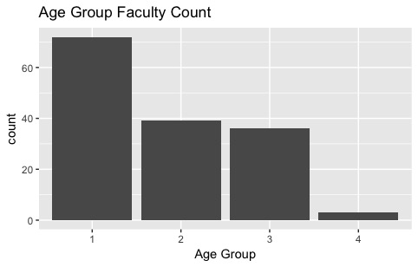

Below graph consists of the proportion of the age groups in each gender. From the graph, we can observe that most of the faculty with age group 1 are male than female. If we compare the proportion of age groups in each gender itself, we can observe the faculty that are under age group 1 are more in male than any other age group.

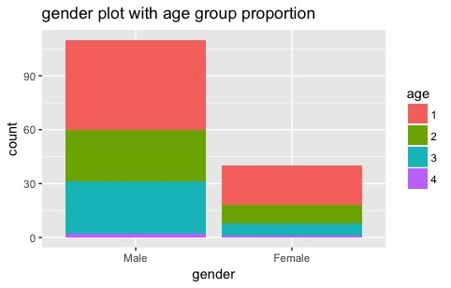

If we look at the education, most of the faculty are Post graduates. From the graph for the given dataset we can establish a statement that most of the faculty at the higher education possess no less than a post graduate degree, as there are only few faculty that have an education level less than post graduate.

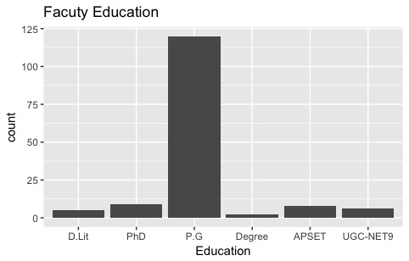

The below graph consists of the proportion of education level with each age group. Surprisingly, people who have an education level more than Ph.D. are under age group 1.

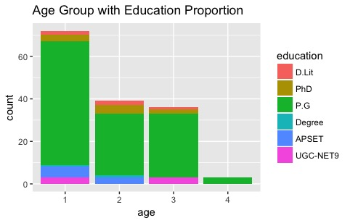

Now let us consider the average publications published by each faculty from each group. Below we can observe that most of the publications are done by the age group 2. While the second most publications are done by age group 1 and age group 3.

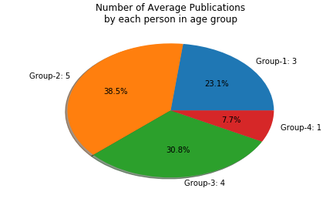

In the below graph, we can observe the average number of activities; the faculty are participating by each faculty according to the age group. We can see that the highest involvement of faculty in activities is by age group 2.

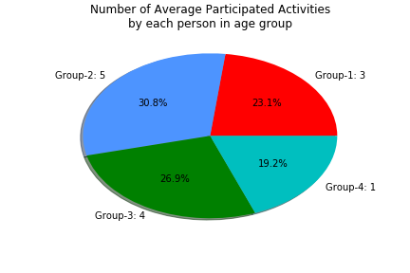

If we look at the below graph, we can observe that the most average number of activities that are conducted by each faculty belong to age group 2. Additionally, group 3 and group 1 have the same number of conducted activities. Although the experience gathered by the faculty who belong to age group 1 has less than compared to group 3, they share the equal number of conducted activities.

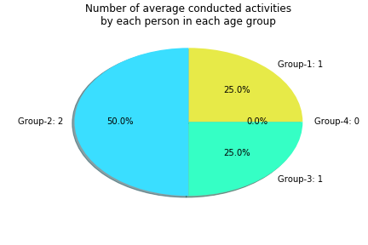

From the below graph we can observe that most average number of activities are attended by each faculty belong to group 2. Group 3 comes second while group 1 and group 4 share the same number.

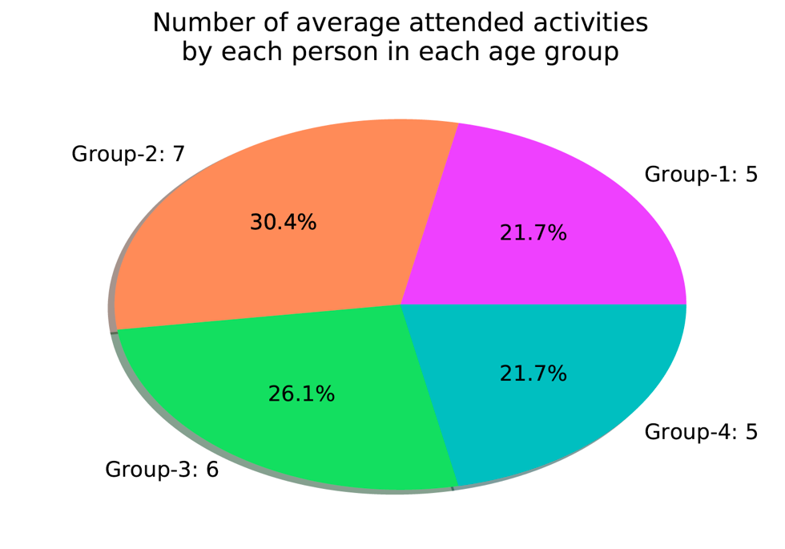

Considering the overall satisfaction of the faculty, from the below graph, we can observe that the faculty are satisfied with their present job in the organization.

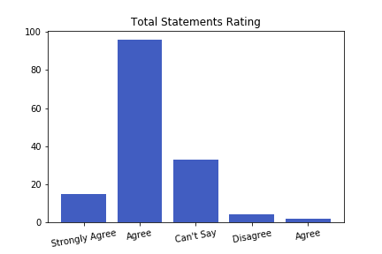

I have appointed scores for each rating, such as ‘Strongly Agree’ is marked +2 points, ‘Agree’ is marked +1 point, ‘Can’t Say’ is marked as 0 points, ‘Disagree’ is marked as -1 and ‘Strongly Disagree’ is marked as -2 points. So, the number people adds up to the total points secured by each statement.

After scoring all the statements. Top 5 statements that all the faculty satisfied with are:

*Statement-1*: *Your Organization encourages you to participate in all types of conferences /seminars.*

Score: 197

*Statement-2*: *Your Organization encourages you to conduct all types of conference/ seminar.*

Score: 195

*Statement-13*: *Your organization supports you with ICT (LCD Projector/Digital etc.,) facilities in classrooms.*

Score: 190

*Statament-28*: *You feel that your job is challenging and interesting.*

Score: 176

*Statement-3*: Your Organization encourages you to attend FDP’s regularly.

Score: 170

Top 5 statements that faculty are not satisfied with:

*Statement-22*: *You opted teaching career only because of financially lucrative*.

Score: -100

*Statement-21*: *You opted teaching career only because of financially lucrative.*

Score: -60

*Statement-27*: *You opted teaching career only because of timings are convenient for work life balance.*

Score: 17

*Statement-8*: *You opted teaching career only because of timings are convenient for work life balance.*

Score: 20

*Statement-20*: *You opted teaching career only because of timings are convenient for work life balance.*

Score: 21

**Conclusion:**

The dataset comprises of three age groups ranging from 21 to 30 in age group 1, 31 to 40 in age group 2, 41 to 50 in age group 3 and 51 to 60 in age group 4. Since, the faculty from the age group 3 and 4 are near to their retirement age, they might probably be less active in career planning activities. Whereas the remaining age groups, in order to excel in their career, they must be aware of the updating knowledge and be active in participating different educational activities. Accordingly, the faculty must be involved in conducting the conferences and also attend multiple conferences. Additionally, the profile of a faculty optimizes if he/she has published some work.

In case of the publications, we can observe from the analysis that most of the published work is done by the age group 2. Astonishingly, we might expect that the faculty with higher age might have more published work, but in the case of age group 4, they stand last in the pool.

When we consider the number of average activities participated by the faculty, age group 2 has more activities participated than the other three groups.

While in terms of average number of conducted activities by each faculty, age group 2 has the highest number of conducted activities. In order to conduct a conference by a faculty, he/she must have sufficient experience to do so. But, even though faculty from age group 1 has less experience than compared with the other three groups, they have the same number of conducted conferences when compared with age group 3. Astonishingly, faculty who belong to group 4 has no conducted conferences.

If we consider the average attended activities by each age group, age group 2 has the highest number.

From the above analysis, we can emphasize that the faculty are aware and active in revamping their teaching career. Though the age group 1 numbers are low, but when compared with other groups, their numbers are very much near. We can also state that when the faculty are in the age range of 31 to 40 years (age group 2), they are much active to refine their career.

Finally, we cannot accentuate any statement on faculty that belong to age group 4 because of their unexpected results. As, we do not have enough data for analysis to conclude a statement upon.